TAI CHI CLASS FOR BEGINNERS

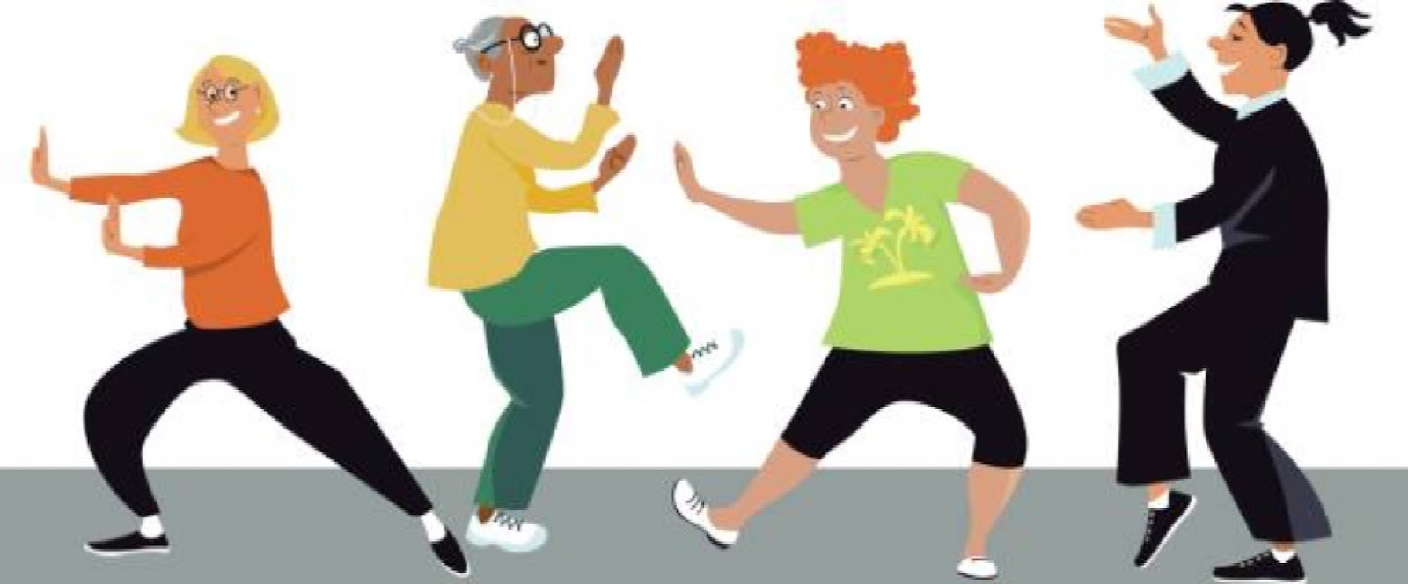

NEWCASTLE LEISURE CENTRE
STARTING FRIDAY 10th Jan 2020
(Free 12 week programme)
3.30PM – 4.30PM
To book a place or find out more information please contact a member of the Multi- Disciplinary Team in your Local GP Surgery.
Or
County Down Rural Community Network
On 028 4461 2311

